ASSIGNMENT 6

1. ***What are the various elements of the Excel interface? Describe how they're used.***

**Ans.** The interface components of excel includes the following:-

* *QUICK ACCESS TOOLBAR*

The quick access toolbar is found on the top-left of the Excel window which contains the commonly- used commands in excel.

This toolbar can be customized and lets you choose which commands you want to access easily. By default, this contains the **save, undo, redo** commands.

* *RIBBON*

This has multiple tabs including the **file, home, insert, page layout, formulas, data, review, view, add-ins, and help** tabs. There are tabs that will appear when necessary; for example, the ***format******tab*** appears when you click an inserted shape.

The tabs are then subdivided in groups based on the usage of the commands. For example, in the home tab, the commands are grouped in clipboard, font, alignment, number, styles, cells and editing.

* *NAME BOX*

It displays the name or location of the active cell on the worksheet. This is also used to directly create a named range. When you open a blank workbook, the selected cell is A1, by default.

* *FORMULA QUICK MENU*

The formula quick menu beside the name box is a shortcut when you want to insert a function. If you click the **fx** option, the insert function will pop up to let you choose which excel function would you like to use.

* *FORMULA BAR*

It is found just beside the formula quick menu. This allows you to **enter or edit data, formula or a function** that will appear in the selected cell whose name or location appears in a name box.

* *STATUS BAR*

The status bar in the bottom left corner of the excel window displays various information about the current mode of the workbook.

* *WORKSHEET VIEW OPTIONS*

This lets you choose which of the 3 worksheet views you want

**(normal , page layout, or page break preview).** By default, the worksheet view is set to normal.

* *ZOOM SLIDER CONTROL*

Helps you **zoom in and zoom out** the worksheet.

* *ZOOM PERCENTAGE INDICATOR*

Displays the zoom percentage just beside the zoom slider control. By default, it is set to 100%.

1. ***Write down the various applications of Excel in the industry.***

***Ans.*** various applicatuions are as follows:-

* *DATA ENTRY AND STORAGE (***customer mailinig list, employees work reports, employees shift rotations, salary data, etc.**)
* *PERFORMING CALCULATIONS* ***(*financial, logical, text, date & time, math, and trigonometry, etc.)**

With excel, we can perform almost every type of calculation (**addition, subtraction, multiplication, division, etc.**)*DATA ANALYTICS AND INTERPRETATION* **(formulae and pivot tables** to effectively analyse the data and interpret the numbers**).**

By usimg these features,we caj consolidate the datta and easily focus on essential segments from large data sets.

By applying features like **sort, filter, or swapping out data segments,** the table can be managed more systematically to carry out the required data fields. Furthermore, we can take a screenshot of the specific part and attach it to a particular area in excel to create an interactive summarized report with precise communicable results.

* *REPORTING AND VISUALIZATIONS (***charts, graphs, specific colour styles, axis values, text comments, etc**).
* *ACCOUNTING AND BUDGETING* (account and budget managers most often use MS excel to **maintain customer records.)**
* *CALENDARS AND SCHEDULES (*Another important use of excel can be seen in making calendars and schedules. Excel offers some auto features that can help in developing sequential dates or days accordingly. We are not required to enter all the dates or days manually. Additionally, we can adequately organize dates and days using rows and columns in excel to **create a well-formed calendar**. Once the calendar is created, we can also use comments or texts to add schedules or tasks for specific dates or days accordingly.)
* *ADMINISTRATIVE AND MANAGERIAL DUTIES (*One of the significant aspects of administrative or managerial duties is to create and maintain multiple business processes. MS Excel is the solution. The software is not just used for recordkeeping anymore. It is beneficial in office administration for many other **tasks, such as invoicing, paying bills, keeping track of profits, loss, expenses, etc**.)

**Many more applications we can perform in excel according to our requirement.**

1. ***On the ribbon, make a new tab. Add some different groups, insert commands in the groups and name them according to their commands added. Copy and paste the screenshot of the steps you followed.***

**Ans.** 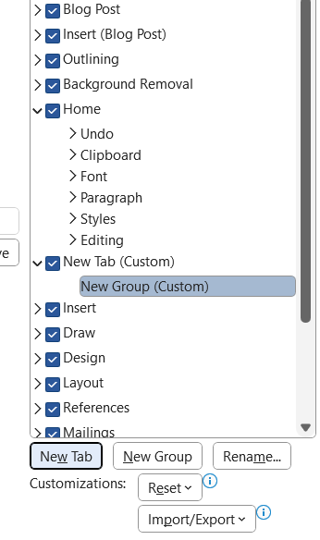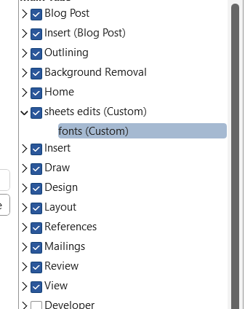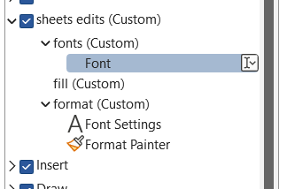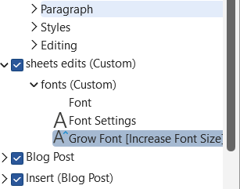

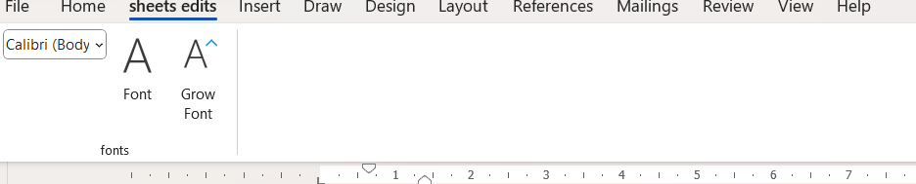

1. ***Make a list of different shortcut keys that are only connected to formatting with their functions.***

***Ans.* Ctrl + 1** - Open the Format Cells dialog box.

**Ctrl + 2** - Apply or remove the bold format to a cell or range of cells.

**Ctrl + 3** - Apply or remove the italic format to a cell or range of cells.

**Ctrl + 4** - Apply or remove the underline format to a cell or range of cells.

**Ctrl + 5** - Apply or remove the strikethrough format to a cell or range of cells.

**Ctrl + B** - Apply or remove the bold format to a cell or range of cells.

**Ctrl + I** - Apply or remove the italic format to a cell or range of cells.

**Ctrl + U -** Apply or remove the underline format to a cell or range of cells

**Ctrl + Shift + !** - Apply the thousands comma with two decimal places number format to a cell or range of cells.

**Ctrl + Shift + #** - Apply the date format to a cell or range of cells.

**Ctrl + Shift + $** - Apply the currency format to a cell or range of cells.

**Ctrl + Shift + %** - Apply the percent format to a cell or range of cells.

**Ctrl + Shift + &** - Apply outside boarders to a cell or range of cells.

**Ctrl + Shift + @** - Apply the time format to a cell or range of cells.

**Ctrl + Shift + _** - Remove all borders from a cell or range of cells.

**Ctrl + Shift + ~** - Apply the general format to a cell or range of cells.

**Ctrl + Shift + F** - Open the Format Cells dialog box with the Font tab active.

**Ctrl + Shift + P** - Open the Format Cells dialog box with the Font tab active.

1. ***What distinguishes Excel from other analytical tools?***

***Ans.*** The excel spreadsheet displays financial information in an organized manner. The information could be related to the sales, management department, HR or the marketing. Most of the businesses are dependent on IT sector and therefore excel is a vital tool to run a business. Read on to learn about the topmost features of this software.

* It builds the charts
* It makes use of conditional formatting
* It helps to organize the data
* It will identify trends
* It provides online access

Excel will use range of formulas to unlock the potential of data. You have to insert data in individual cells of columns and rows. In this way, data will be filtered and sorted and hence displayed in a presentable manner. Different types of charts like clustered columns, graphs and pie chart provide great visual presentation. It puts more emphasis to marketing material and business reports. Excel is a wonderful tool to represent data on X and Y axis.

It provides different color shades, font types to format the spreadsheet and differentiate between rows and columns. It is good to present useful presenting information such as balance, tax profit etc. There is a quick analysis button to choose the appropriate colouring scheme.   
  
You could combine the information from different files and documents to Excel. In this way, they will exist in a single location. Besides the regular information and raw data from spreadsheets, it is easy to import the images too. You just need to use the insert tab to add multiple objects to the spreadsheet.

1. ***Create a table and add a custom header and footer to your table.***

Ans. 